How the Microsoft Authenticator app will work when you are trying to access your SRC account from outside the college.
Once installed, when you try to access your SRC account or any SRC system remotely, the device you are using will display a prompt similar to the one below
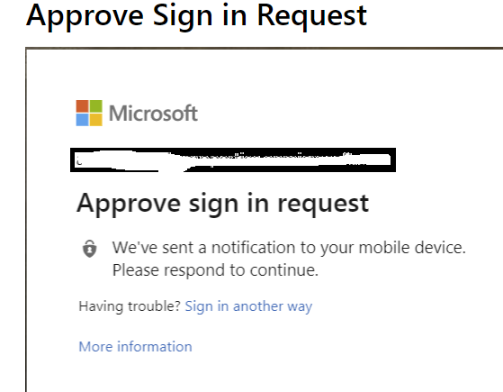
At the same time on your mobile phone you will receive a message asking you to approve or deny the request, see screen shots below.

Notice Authenticator App symbol at top of screen, highlighted in red here - pull screen down to see notification (next screenshot) | Click approve only if you are trying to access your account remotely, if you are not trying to access, do not approve the attempt. | Alternatively you may just get a prompt like this one on your mobile phone. Again, only approve if you are trying to access, click Deny if you are not trying to access as this means someone else is attempting to access your account.
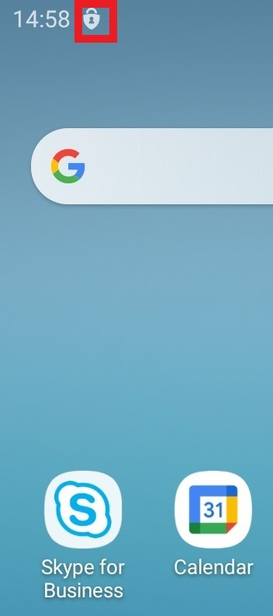 | 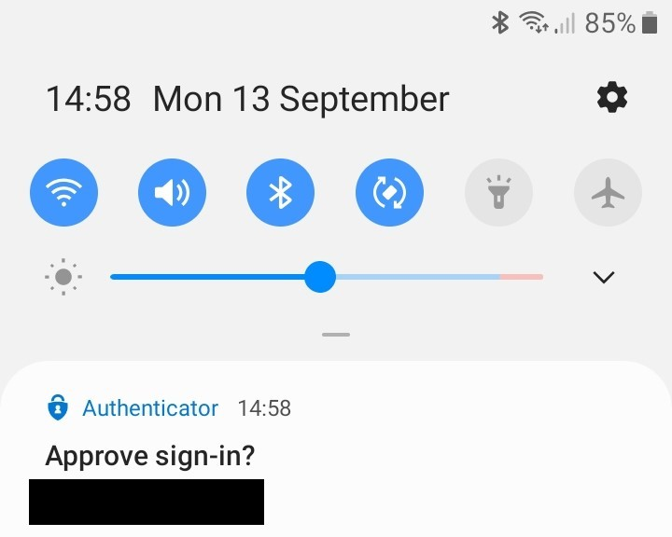 | 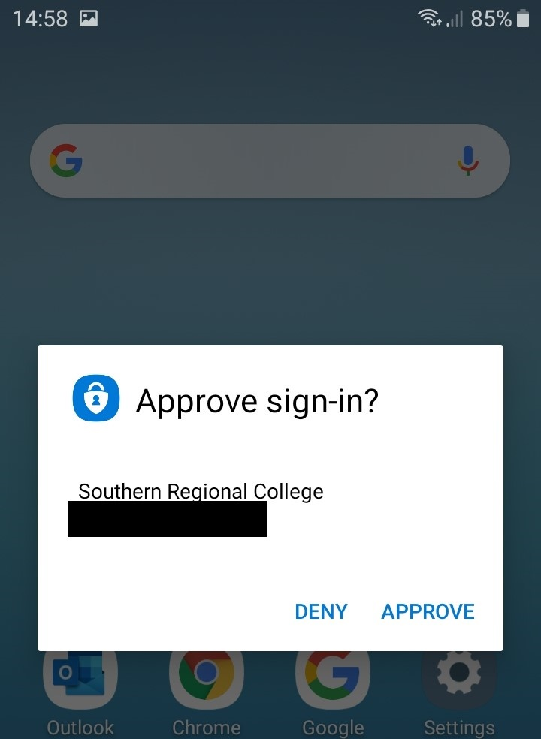

If you were trying to access, then you can select Approve. This will then allow you access to whatever part of your SRC account or system you were trying to access.
If you were not trying to access, then you MUST SELECT DENY and inform your tutor and itservices@src.ac.uk asap and change your SRC password as soon as possible as this means someone else was trying to access your account.

